**Learn in Community**

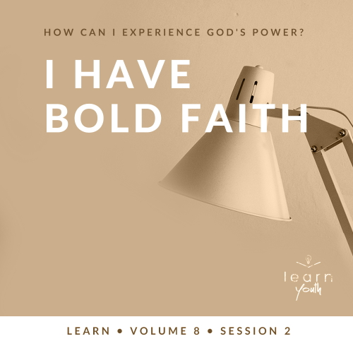

Small Group Study



**Volume Overview**

**How can I experience God’s power?**

“I tell you the truth, anyone who believes in me will do the same works I have done, and even greater works, because I am going to be with the Father.” ([John 14:12](https://ref.ly/logosref/Bible.Jn14.12))

*For this volume, we’ll focus on God’s power. More specifically, we’ll ask and address the question: How can I experience God’s power in my life? Even a skim through the Bible reveals that God expresses His power in many ways. From Genesis to Revelation, the entire Bible is filled with accounts of impossible things becoming possible with God. And God’s power continues in believers’ lives today. We can experience miracles, have bold faith, believe for healing, and know God answers our prayers.*

|  |
| --- |
| ***You Will Need***  *• Optional: Small prize for the winner of the game*  ***Getting Ready***  *• First time leading* Learn *for Youth? Look here for the* [Facilitator Guide](https://0b769b0ed3569ef9d18b-f88d8272f61086866d50d048b43ef630.ssl.cf2.rackcdn.com/sites/biblengagementproject/Listen_Facilitator_Guide.pdf)*.* |

To access session content and videos from a computer, visit: [BibleEngagementProject.com/downloads](https://bibleengagementproject.com/downloads)

**Engage**

**Welcome**

*Take this time to welcome everyone, introduce new students, learn names, and thank everyone for coming. Your friendliness here can create comfort levels that encourage student participation later.*

|  |
| --- |
| **QUESTION**  If you could train with or learn from someone you really admire for one day, who would you choose and why? |

**Opening Prayer**

*Prayer thoughts: Thank the Lord for the students who are present and for their protection this week. Thank God for His desire to partner with us in demonstrating His power. Spend a few moments praying for bold faith for those who are present.*

**Introduction**

Did you know that God wants you to be a part of people’s lives being changed, experiencing miracles, and His power being revealed? But, one requirement for this is that we become people of faith. We exercise faith when we trust God regardless of our situation or what anyone else says. We’re all at different levels of faith, and that’s okay. God can use even small faith to display His power in the world. Our objective in this session is to learn about experiencing God’s power and to have bold faith in Him.

**Group Activity**

**Live Sequence**

|  |
| --- |
| ***You Will Need***  *• Optional: Small prize for the winner of the game*  *No prep is needed.* |

Let’s start with a game. As the leader, I’ll call out a command, and you’ll do it. Then I’ll call out the second command, and you have to do the first and second commands. For example, if the first command is, “Say red,” and the second command is, “Grab your elbow,” you must say, “Red,” and then grab your elbow.

The goal is to keep following all the commands in sequence. If you get the sequence wrong, you’re out. The person who can do the most commands in sequence wins. When you’re eliminated, you can help me watch to see who is getting the sequence right.

• *Here are several commands. Add more commands or create your own list as desired.*

1. Say, “Red.”

2. Grab your elbow.

3. Tap the shoulder of someone next to you.

4. Say, “Five.”

5. Scratch your head.

6. Lift one leg.

7. Say, “Two plus two equals four.”

8. Shake hands with someone.

9. Jump two times.

10. Say, “Alligator.”

11. Laugh.

12. Touch your nose.

13. Spin around.

14. Say the name of a book from the Bible.

15. Touch your toes.

• *Optional: Award a prize to the winner.*

In a few moments, we’ll read a passage from the Old Testament that has a similarity to the game we just played. See if you can pick up on the similarity. Now, let’s watch the video.

**Watch**

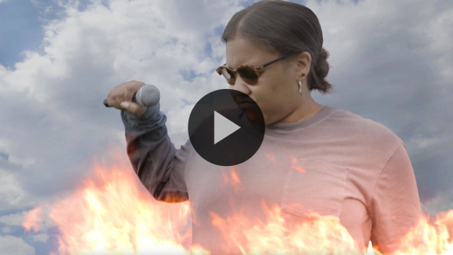

**Consider What the Bible Says**

*Ensure each student has access to a Bible, preferably the same version.*

Let’s talk about the details of the relationship between Elijah and Elisha, and how their relationship with God led to bold faith. Last time we looked at Elijah. He confronted King Ahab and said it wouldn’t rain. Then God miraculously provided food for Elijah in an unusual way. Elijah showed us how God desires our obedience and trust in Him. Soon we’ll see how his faith rubbed off on his follower, Elisha.

**Surround Yourself with Others Who Have Bold Faith**

Read [2 Kings 2:6–8](https://ref.ly/logosref/Bible.2Ki2.6-8).

In [1 Kings 19](https://ref.ly/logosref/Bible.1Ki19), God told Elijah to go and find Elisha. Elisha, the younger man, would replace Elijah as the prophet for God’s people, but they would spend time together before that happened. Elijah was the teacher, mentor, and spiritual father. Elisha was the student, trainee, and spiritual son.

|  |
| --- |
| **QUESTION**  What did Elisha demonstrate when he refused to stay like Elijah told him to? |

One of the signs of a committed disciple is persistence. Persistence and determination lead us toward bold faith.

|  |
| --- |
| **QUESTION**  What do you think Elisha felt when he saw Elijah strike the Jordan River with his cloak (cape) and watched the waters divide? |

|  |
| --- |
| **QUESTION**  Why do you think it was important for Elisha to witness that? |

|  |
| --- |
| **QUESTION**  Why is it important for followers of Jesus to have a mentor or spiritual leader in their life? What makes you say this? |

|  |
| --- |
| **QUESTION**  Why do you think it’s important for us to be around other people with bold faith? |

Just like Elisha stayed with Elijah, being around others with bold faith gives us opportunities to see faith in action. And those opportunities can help our faith grow. These people challenge us through their words and actions to expand our trust in God and His power.

|  |
| --- |
| **QUESTION**  Do you know someone close to you who has bold faith? Tell us a little about them and your relationship with them. |

**Choose to Take Bold Steps of Faith**

Read [2 Kings 2:9–12](https://ref.ly/logosref/Bible.2Ki2.9-12).

Elijah was miraculously taken to heaven in a whirlwind. It must have been a dramatic and incredible thing for Elisha to see. His persistence to stay close to a person of faith put him face-to-face with the miraculous appearance of fiery horses, chariots, and charioteers. It had a profound impact on Elisha’s faith.

|  |
| --- |
| **QUESTION**  What would you guess Elisha was asking for when he asked for a “double share” from Elijah? |

When Elisha asked for a “double share,” he was requesting a spiritual inheritance from Elijah, like a firstborn son. He was requesting the power to fill Elijah’s shoes as a prophet.

|  |
| --- |
| **QUESTION**  What does this tell us about Elisha’s boldness? |

|  |
| --- |
| **QUESTION**  What can Elisha’s request teach us about our own requests to God? |

|  |
| --- |
| **QUESTION**  Have you ever taken a bold step of faith? Can you tell us about it? |

It’s tough to take bold steps of faith if we don’t believe God is who He says He is. But seeing and hearing about the faith of others can strengthen our belief. Elisha first learned from Elijah’s faith. Eventually, it was time for Elisha to step out with his own bold faith.

**Did You Know?**

|  |
| --- |
| Elijah’s gift from God of seemingly being spared a natural death served as a major point of focus surrounding Elijah in the New Testament period. Elijah, along with Enoch, became key figures in non-biblical, Jewish literature, specifically in the Apocalyptic genre. These two men were described as serving a unique purpose for the Messiah (and the Second Coming for Christians). This connection continues today during the celebration of Passover. Modern Jews leave a seat open in case Elijah appears and wants to eat with them, heralding in the Messiah (or return of the Messiah for Messianic Jews). |

**Trust That God Will Honor Your Bold Faith**

Read [2 Kings 2:13–15](https://ref.ly/logosref/Bible.2Ki2.13-15).

Elijah’s cloak was a symbol of his office as God’s prophet. It was first laid on Elisha to show that he was chosen to follow in Elijah’s footsteps as a prophet ([1 Kings 19:19](https://ref.ly/logosref/Bible.1Ki19.19)). Now, the original owner of the cloak was gone, and it fell to its new owner.

|  |
| --- |
| **QUESTION**  Why was it important that Elisha picked up the cloak? |

|  |
| --- |
| **QUESTION**  As a young person, what can you learn from Elisha closely following Elijah? |

Because Elisha had just watched Elijah strike the Jordan River, Elisha did the same thing. He picked up the cloak and struck the water in faith just as he had seen his mentor do.

|  |
| --- |
| **QUESTION**  On a scale of 1–10, with 1 being sure it wouldn’t happen and 10 being completely confident it would, how confident do you think Elisha was that the river would divide? |

God can move miraculously through us just like He has for those before us, but we must be willing to learn from them. We can also learn from Elisha. We can trust that God will honor our faith.

|  |
| --- |
| **QUESTION**  Why do you think it was important that the group of prophets affirmed that Elisha was acting in the same spirit as Elijah? |

Like Elisha, others who are close to God may see God working in our life. They may recognize and affirm His presence, anointing, and plans before we do. Not only should we trust that God will honor our bold faith, but He also may bring the right people into our life to guide and encourage us too.

|  |
| --- |
| **QUESTION**  Have you ever had someone affirm God at work through you? Tell us about it. |

**Reflect**

**I Have Bold Faith**

Let’s revisit some of the important truths we learned from today’s Bible account. First, we should be intentional about identifying people who have bold faith and building a relationship with them. We have much to learn, and it’s wise to surround ourself with people who can help us grow. We must also have our own bold faith that trusts that God will do amazing things in and through our life. Finally, we can completely trust God when we step out in bold faith that honors Him. This allows us to experience His incredible power.

**Listen to God**

Let’s take time to consider how our life demonstrates what we’ve learned from this Bible passage. These questions are meant to serve as a conversation between you and God. Sharing your responses with the group is completely voluntary.

• *Pause for a few moments of silent reflection before asking students if they want to share.*

|  |
| --- |
| **QUESTION**  What is a bold step God is asking you to take right now? |

|  |
| --- |
| **QUESTION**  Who is someone you can watch and learn from like Elisha learned from Elijah? |

**Activate**

If we’re going to be a part of God’s plans, we have to do the part He is calling us to do. It’s time to put what we’ve learned into action.

|  |
| --- |
| **QUESTION**  What is one thing you can do this week to start applying this lesson about bold faith? |

**Conclusion**

Being a Christian means that your entire life is spent becoming more like Jesus Christ. Part of that process often involves people who can help you down that path. I’m challenging you to find someone to watch and learn from, then put into practice what you learn.

|  |
| --- |
| **Salvation Opportunity**  Include this if you think there may be some in the group who do not have a personal relationship with Jesus.  *Often, the boldest step of faith is to truly believe that God loves you and wants to have a relationship with you. It takes courage to trust that He knows what’s best for you and surrender your life to Him. Today can be the day that you start down the path of faith with your friends in this group.*  **Is there anyone here that we can pray for who doesn’t have a relationship with Jesus or wants to renew their relationship with Him?**  *Take a moment to acknowledge those who respond, and thank them for their desire to make things right between themselves and God. Pray with them after you close in prayer or after the group time is over. Following group time, talk more about where they are in their walk with God and how you might be able to help.* |

**Prayer**

Father, we’re so grateful that through faith we get to be part of Your amazing plans. We’re also grateful for the people You bring into our life who help us grow in faith. Help us develop bold faith and surround ourself with the right people who will challenge and mentor us. In Jesus’ name I pray. Amen.

Don’t forget your devotions this week! Bold faith is often developed in places where only God sees. All the devotions are available on the Bible Engagement Project app.